CAI, Chusheng (January 12, 1906—July 15, 1968)

Cai Chusheng was a Chinese film director and screenwriter and a leading figure in the Chinese progressive [*jinbu*] cinema of the 1930s and 1940s. His oeuvre includes *Yú guāng qǔ* [*Song of the Fishermen*, 1934], the first Chinese film ever to win an international award, and *Yī jiāng chūn shuǐ xiàng dōng liú* [*The Spring River Flows East*, 1947], which was the highest grossing film in 1940s China (Zhou 2009: 9). Cai’s life and career were parallel to and embedded in the most turbulent period of modern Chinese history. Western colonization, the second Sino-Japanese War, and the Chinese Civil War left the traditional Chinese social order in total ruin. Through filmmaking, Cai took part in intense discussions over the reconstruction of modern China. His elaboration of modernity, however, proved to be conflicted and unsettled, a condition that paradoxically reflected the unique form of modernization in China, which negotiated collective national identity through class struggle and the proletarian revolution. In his films, we often observe that his protagonists’ devotion to the suffering masses cannot be reconciled with their individual sentimentality; their patriotic life fails to transcend their unfulfilled desire, and/or their creation of a new future is hindered by the resurrection of a traumatic past. Yet, because of these contradictions, his films are at once earthy and poetic and his characters strong and yet vulnerable. Cai’s great honesty about the complexity of human motivation shines through, and his characters’ humanism emerges from behind the propaganda about national salvation and reliance on a strong notion of collectivism.

**References and further reading:**

Hong, G. (2007) ‘Framing Time: *New Women* and the Cinematic Representation of Colonial Modernity in 1930s Shanghai’, *East Asia Cultures Critique* 15 (3): 553-579.

Pang, L. (2002) *Building a New China in Cinema: The Chinese Left-wing Cinema Movement, 1932-1937*, Lanham: Rowman & Littlefield.

Pickowicz, P. (2012) C*hina on Film: A Century of Exploration, Confrontation, and Controversy*, Lanham: Rowman & Littlefield.

Pickwicz, P (1993) ‘Melodramatic Representation and the “May Fourth” Tradition of Chinese Cinema’, in Widmer E. and Wang D. (ed.) *From May Fourth to June Fourth: Fiction and Film in Twentieth Century China*, Cambridge, MA: Harvard University Press.

Shen, V (2005) *The Origin of Left-wing in China, 1932-37*, New York: Routledge.

Zhang, Y. (2004) *Chinese National Cinema*, New York: Routledge.

Zhou. X. (2009) '启承与变革——论新时期以来大陆伦理片的发展与演变' [Tradition and Transformation—A Reflection on the Evolution of Melodrama in Mainland China]. Available from: CNKI机构馆在线. [Accessed 5 April 2013].

**List of works:**

*Nán guó zhī chūn* (*Spring in the South,* 1932)

*Gòng fù guó nàn* (*Facing the National Crisis*, 1932)

*Fěn hóng sè dè mèng* (*Pink Dream*, 1932)

*Dū huì* *dè* *zǎo chén* (*Dawn Over the Metropolis*, 1933)

*Yú guāng qǔ* (*Song of the Fishermen*, 1934)

*Xīn nǚ xìng* (*New Women*, 1935)

*Mí tú dè gāo yáng* (*Lost Lambs*, 1936)

*Wáng lǎo wǔ* (*Fifth Brother Wang*, 1937)

*Gū dǎo tiān táng* (*Orphan Island Paradise*, 1939)

*Qián chéng wàn lǐ* (*Boundless Future*, 1941)

*Yī jiāng chūn shuǐ xiàng dōng liú* (*The Spring River Flows East*, 1947),

*Nán hǎi cháo* (1963)

**Paratextual material:**

Images:

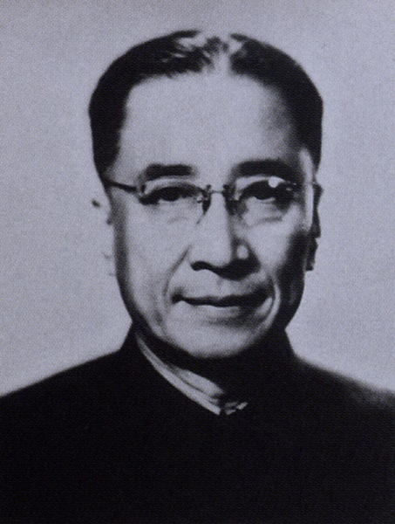

Figure 1 Cai Chusheng

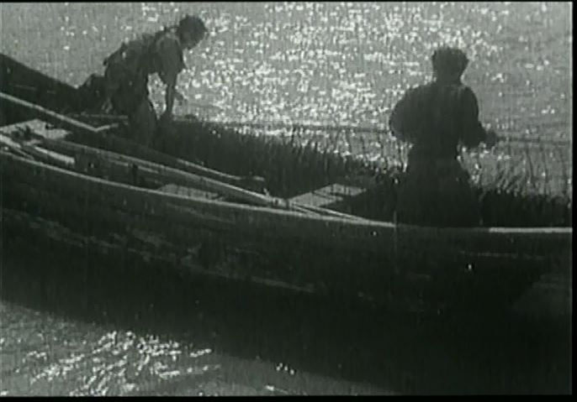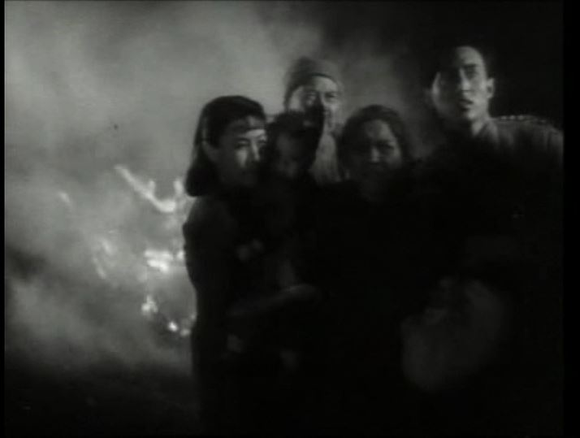

Figure 2 Screen Capture from Song of the Fishermen

Figure 3 Spring Water Flows West Screen Capture

**Links:**

Cai Cusheng at the Internet Movie Database <http://www.dianying.com/en/person/CaiChusheng>

Cai Cusheng at 中国电影资料库 (zhongguo dianying zeliao ku) <http://www.imdb.com/name/nm0161529/>

Essay by Chris Berry on the Chinese leftist cinema of the 1930s <http://www.ejumpcut.org/archive/onlinessays/JC34folder/30sLeftChinaFilms.html>

Introduction to China’s Modern History

<https://www.modernhistoryofchina.com/Home_Page.html>

<http://afe.easia.columbia.edu/timelines/china_modern_timeline.htm>

Funing Tang University of Miami